

**Screenshot App**

Contents

1.Introduction 3

2.PRE-INSTALLATION CHECKLIST 3

3.System Requirements 3

4.INSTALLATION PROCEDURES 3

5.Configuring the application 3

6.Test the application 5

### 1.Introduction

#### 1.1Overview

This document is to provide the application running manual for ASML REST SERVICE API image data fetching.

### 2.PRE-INSTALLATION CHECKLIST

### 3.System Requirements

#### 3.1 Hardware Requirement

* Windows OS

#### 3.2 Software Requirement

* Java

### 4.INSTALLATION PROCEDURES

Please follow the below procedure

### 5.Configuring the application

1. Install the application from ASML_Screenshot _Application
2. Open ASML_Screenshot Application

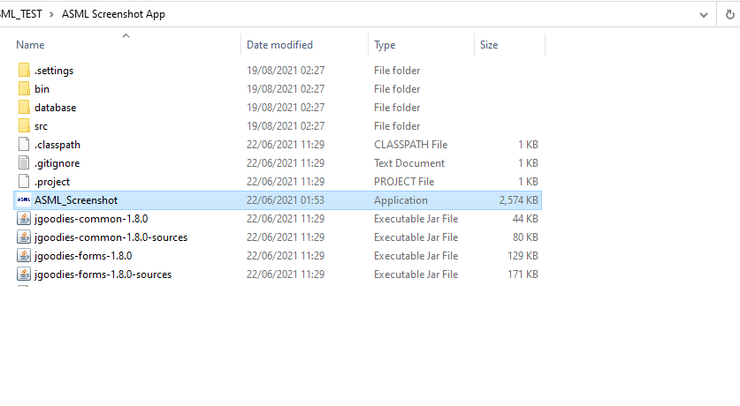

1. You can browse for the desired storage location from Settings tab

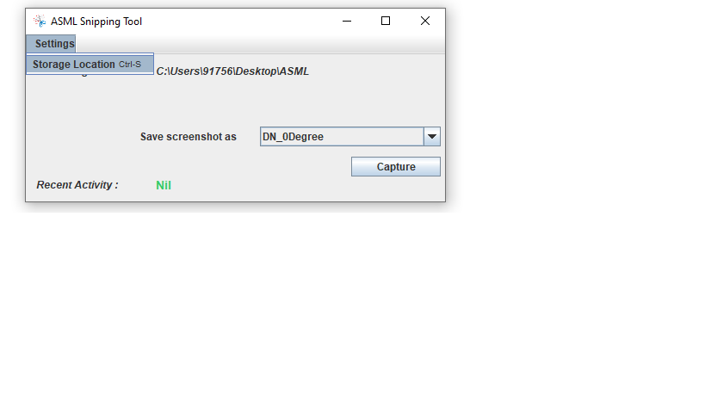

1. Select the file name from “Save screenshot as” label

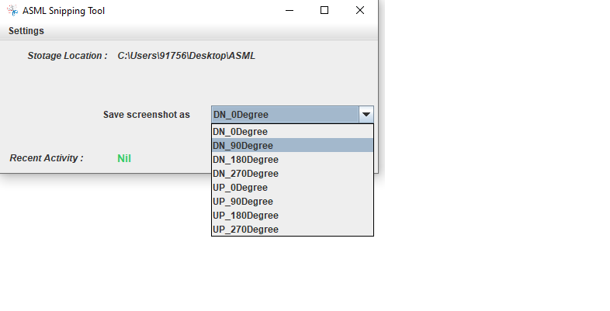

1. Click Capture button to take the screenshot

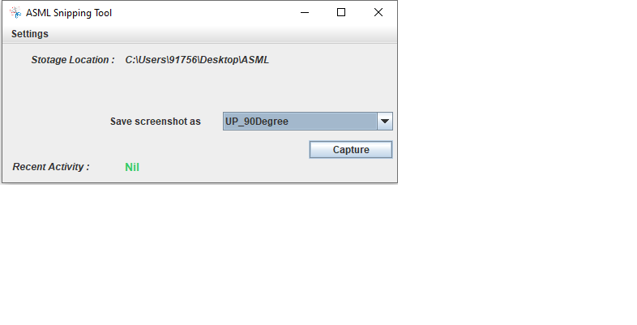

### 6.Test the Application

1. Open the browsed folder to see the saved screenshot in PNG format.

